Fishery Manuscript No. YY-XX
Sockeye Salmon Stock Status and Escapement Goals for Chilkoot Lake in Southeast Alaska

by
Xinxian Zhang,
Randall L. Bachman,
Mark M. Sogge,
and
Harold J. Geiger

month 2006


Alaska Department of Fish and Game Divisions of Sport Fish and Commercial Fisheries

Symbols and Abbreviations
The following symbols and abbreviations, and others approved for the Système International d'Unités (SI), are used without definition in the following reports by the Divisions of Sport Fish and of Commercial Fisheries: Fishery Manuscripts, Fishery Data Series Reports, Fishery Management Reports, and Special Publications. All others, including deviations from definitions listed below, are noted in the text at first mention, as well as in the titles or footnotes of tables, and in figure or figure captions.

Weights and measures (metric)
centimeter cm
deciliter dL
gram g
hectare ha
kilogram kg
kilometer km
liter L
meter m
milliliter mL
millimeter mm

Weights and measures (English)
cubic feet per second ft³/s
foot ft
gallon gal
inch in
mile mi
nautical mile nmi
ounce oz
pound lb
quart qt
yard yd

Time and temperature
day d
degrees Celsius °C
degrees Fahrenheit °F
degrees kelvin K
hour h
minute min
second s

Physics and chemistry
all atomic symbols
alternating current AC
ampere A
calorie cal
direct current DC
hertz Hz
horsepower hp
hydrogen ion activity pH
(negative log of)
parts per million ppm
parts per thousand ppt,
‰
volts V
watts W
General
Alaska Administrative
Code AAC
all commonly accepted
abbreviations e.g., Mr., Mrs., AM, PM, etc.
all commonly accepted
professional titles e.g., Dr., Ph.D.,
R.N., etc.
at @
compass directions:
east E
north N
south S
west W
copyright ©
corporate suffixes:
Company Co.
Corporation Corp.
Incorporated Inc.
Limited Ltd.
District of Columbia D.C.
et alii (and others) et al.
et cetera (and so forth) etc.
exempli gratia
(for example) e.g.
Federal Information
Code FIC
id est (that is) i.e.
latitude or longitude lat. or long.
monetary symbols
(U.S.) $, ¢
months (tables and
figures): first three
letters Jan,...,Dec
registered trademark ®
trademark ™
United States
(adjective) U.S.
United States of
America (noun) USA
U.S.C. United States Code
U.S. state use two-letter abbreviations (e.g., AK, WA)
Measures (fisheries)
fork length FL
mideye-to-fork MEF
mideye-to-tail-fork METF
standard length SL
total length TL

Mathematics, statistics
all standard mathematical
signs, symbols and
abbreviations
alternate hypothesis H_{A}
base of natural logarithm e
catch per unit effort CPUE
coefficient of variation CV
common test statistics (F, t, χ², etc.)
confidence interval CI
correlation coefficient
(multiple) R
correlation coefficient
(simple) r
covariance cov
degree (angular ) °
degrees of freedom df
expected value E
greater than >
greater than or equal to ≥
harvest per unit effort HPUE
less than <
less than or equal to ≤
logarithm (natural) ln
logarithm (base 10) log
logarithm (specify base) log_{2,} etc.
minute (angular) '
not significant NS
null hypothesis H_{O}
percent %
probability P
probability of a type I error
(rejection of the null
hypothesis when true) α
probability of a type II error
(acceptance of the null
hypothesis when false) β
second (angular) "
standard deviation SD
standard error SE
variance
population Var
sample var

Fishery manuscript no. YY-XX
Sockeye Salmon Stock Status and Escapement Goals for Chilkoot Lake in Southeast Alaska

By

Xinxian Zhang and Harold J. Geiger
Alaska Department of Fish and Game
Division of Commercial Fisheries
Juneau, Alaska
and

Randall L. Bachman and Mark M. Sogge
Alaska Department of Fish and Game
Division of Commercial Fisheries
Haines, Alaska

Alaska Department of Fish and Game
Division of Sport Fish, Research and Technical Services
333 Raspberry Road, Anchorage, Alaska, 99518-1599

month 2006

Development and publication of this manuscript were partially financed by grants from the National Oceanic and Atmospheric Administration to fund the Southeast Alaska Anadromous Salmon Project.

The Division of Sport Fish Fishery Manuscript was established in 1987 for the publication of technically oriented results for a single project or group of closely related projects. Since 2004, the Division of Commercial Fisheries has also used the Fishery Manuscript. Fishery Manuscript reports are intended for fishery and other technical professionals. Fishery Manuscript reports are available through the Alaska State Library and on the Internet: http://www.sf.adfg.state.ak.us/statewide/divreports/html/intersearch.cfm This publication has undergone editorial and peer review.

Xinxian Zhang and Harold J. Geiger,
Alaska Department of Fish and Game, Division of Commercial Fisheries,
Juneau Alaska, USA

Randall L. Bachman and Mark M. Sogge
Alaska Department of Fish and Game, Division of Commercial Fisheries,
Juneau Alaska, USA

This document should be cited as:
Zhang, X., R. L. Bachman, M. M. Sogge, and H. J. Geiger.2006. Sockeye salmon stock status and escapement goal for Chilkoot Lake in Southeast Alaska. Alaska Department of Fish and Game, Fishery Manuscript No. YY-XX, Anchorage.

The Alaska Department of Fish and Game administers all programs and activities free from discrimination based on race, color, national origin, age, sex, religion, marital status, pregnancy, parenthood, or disability. The department administers all programs and activities in compliance with Title VI of the Civil Rights Act of 1964, Section 504 of the Rehabilitation Act of 1973, Title II of the Americans with Disabilities Act of 1990, the Age Discrimination Act of 1975, and Title IX of the Education Amendments of 1972.

If you believe you have been discriminated against in any program, activity, or facility, or if you desire further information please write to ADF&G, P.O. Box 25526, Juneau, AK 99802-5526; U.S. Fish and Wildlife Service, 4040 N. Fairfax Drive, Suite 300 Webb, Arlington, VA 22203 or O.E.O., U.S. Department of the Interior, Washington DC 20240.

For information on alternative formats for this and other department publications, please contact the department ADA Coordinator at (voice) 907-465-4120, (TDD) 907-465-3646, or (FAX) 907-465-2440.

TABLE OF CONTENTS
Page
LIST OF TABLES ii
LIST OF FIGURES ii
LIST OF APPENDICES iii
abstract 4
introduction 5
The history of escapement goals for Chilkoot lake sockeye salmon 10
Escapement Goal Analysis 11
Ricker recruitment law 11
Modification of recruitment law 13
The Bayesian approach 13
Errors in the independent variable 13
Structural time series Ricker model 13
Prior distributions for Ricker associated parameters a and b at Chilkoot Lake 14
Process error 14
Chilkoot Lake stock-recruit observations 15
Bayesian model fitting 16
First model: Ricker relationship with observation error 16
Second model: Structural time series Ricker model 19
Escapement Goal Recommendation 22
Stock Status and Discussion 22
references cited 25

LIST OF TABLES
Table Page
Table 1.–The values of Ricker parameter estimates for sockeye stocks in Southeast Alaska from Geiger and McPherson (2004). 14
Table 2,–Annual estimated return by age and total return (in thousands) by brood year from 1976 to 1997, along with escapement of each brood year for Chilkoot Lake. Cook’s distance estimates were calculated from a least-squares fit of a Ricker stock-recruit relationship. We used the unadjusted weir counts as our measure of escapement for each brood year and to estimate returns from each brood year; weir counts were used to increase the number of years in our analysis. 15
Table 3.–The Bayesian inferences about parameter and reference points in the model without autocorrelation terms for Chilkoot Lake. The parameter α is the productivity parameter; S_{m} is stock size that maximizes the recruitment; S_{y} is the estimate of the escapement that will maximize sustained yield. 17
Table 4.–Some key posterior distribution summaries for a structural time series Ricker model for Chilkoot Lake. The percentile refers to the Bayesian posterior distribution. The Ricker α_{t} value is from the posterior distribution for the most recently completed brood year: 1998. The value of S_{m}=1/β is the stock size that produces maximum recruitment, and is the inverse of the Ricker β parameter. Because of the time-varying nature of the α_{t} value, there is no maximum sustainable catch (MSC), but we define the “instantaneous” stock that will produce maximum sustained catch to be the value if α_{t} were to be held constant across time. 19
Table 5 Weekly cumulative escapement goals for Chilkoot Lake. Error! Bookmark not defined.

LIST OF FIGURES
Figure Page
Figure 1.–Upper Lynn Canal with principle sockeye salmon spawning and rearing areas. 7
Figure 2.–Annual escapement of Chilkoot Lake sockeye salmon from 1976 to 2004. 8
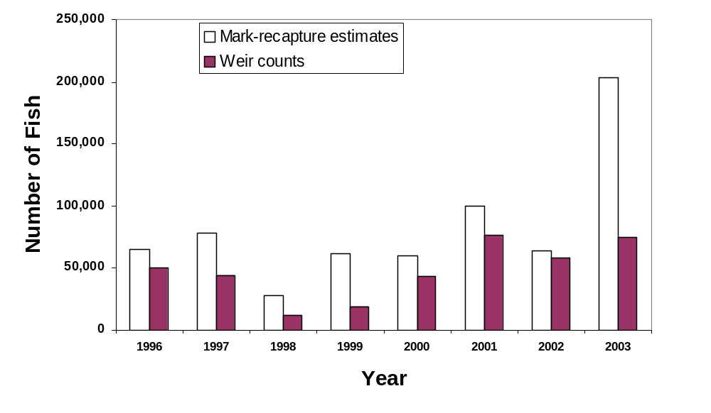 Figure 3.–Comparisons of weir counts and mark-recapture estimates from 1993 to 2003. 9
Figure 4.–Average air temperature in June and July, average euphotic zone depth (EZD, m) from May to October, and average zooplankton density (number in 10 thousands per m²) from May to October. 10
Figure 5.–A conceptual Ricker spawner-recruit curve, relating fish stock size to subsequent recruitment, with three biological reference points noted on the S axis. The value S_{y} denotes the stock size that will maximize catch (MSC), the value S_{m} denotes the stock size that will maximize recruitment, and the value S_{e} denotes an equilibrium point. 12
Figure 6 The estimated number of returns-per-spawner for Chilkoot Lake (plotted with a solid line) together with the proportion of 3- and 4-year old adults in the returns (dashed line) from each brood year. 16
Figure 7.–Posterior distributions for Ricker model parameters α (on the left) and β (on the right) for Chilkoot Lake. 17
Figure 8.–Spawner-recruitment observations for Chilkoot Lake, together with the Ricker relationship, which shows continuous increase in recruitment throughout the range of observed escapements. Note the inability of this model to determine the stock’s carrying capacity. 18
Figure 9.–Residuals for a Bayesian Ricker model developed without a time series component for Chilkoot Lake. The median, 2.5, and 97.5 percentiles refer to the posterior distributions of the Ricker parameters. 18
Figure 10.–Autocorrelation of logarithm of recruits per spawner for Chilkoot Lake. This pattern indicates a first order autoregressive process. 19
Figure 11.– Residuals for a Bayesian Ricker model developed with a time series component for Chilkoot Lake. The median, 2.5, and 97.5 percentiles refer to the posterior distributions of the Ricker parameters. 20
Figure 12.–Estimated median time-indexed Ricker productivity parameter for a structural time series Ricker model. 21
Figure 13.–Comparison of four year-specific stock-recruit relationships, generated by using time-indexed Ricker α values from a structural time-series model. Lines are model predictions for the 1994 to 1997 brood years and dots show all stock-recruit observations. 21

LIST OF APPENDICES
Appendix Page
Appendix A 1.–Sample appendix title Error! Bookmark not defined.

abstract
The Chilkoot Lake sockeye salmon stock has been monitored and managed since 1970s and the status of the stock is unfavorable from a fisheries management perspective. The stock’s downturn in productivity stated with the 1989 brood year and continued to decline, uninterrupted, until about 1995 brood year. We found the possible link to this downturn is the low zooplankton measurements due to changes in freshwater conditions by local warming. Although the stock’s productivity has changed quickly in the recent past, the escapement goal has not been updated for 10 years. In order to recommend a biological escapement goal for the stock, we attempted to develop a Ricker stock-recruit relationship in a Bayesian framework with extensive modifications to allow time-varying parameters and errors in stock size measurements. However, we found the Ricker stock-recruit analysis failed to lead to a reliable estimate of escapement size that produces a maximum sustainable catch. We concluded that the current Chilkoot Lake system is too unstable to produce a predictable maximum sustainable catch. Therefore, a biological escapement goal for the stock cannot be recommended at this time. Alternatively, we recommend the escapement goal for the Chilkoot Lake stock remain essentially unchanged and be classified as a sustainable escapement goal.
Key words: Chilkoot Lake, sockeye salmon, escapement, escapement goal, stock-recruit relationship, Bayesian, maximum sustainable catch.

introduction
The Chilkoot and Chilkat river watersheds are the primary producers of sockeye salmon (Oncorhynchus nerka) caught in the Lynn Canal area of Southeast Alaska (Figure 1). Between 1900 and 1920, the average harvest of sockeye salmon in northern Southeast Alaska was 1.5 million fish; the majority of this harvest was believed to originate from the Chilkat and Chilkoot lakes (Rich and Ball 1933). In comparison, the average sockeye harvest for northern Southeast Alaska from 1980 to 2002 was only 400,000 fish, of which an average of 100,000 and 110,000 fish originated from the Chilkat and Chilkoot lakes, respectively (Geiger et al. 2003).
Chilkoot Lake (59°21′16” N, 135°35′42” W) is glacially turbid, has a surface area of 7.2 km² (1,734 acres), mean depth of 54.5 m, a maximum depth of 89 m and a total volume of 382.4 x 10⁶ m³. The lake outlet is at the head of Lutak Inlet located approximately 16 km northeast of the city of Haines, Alaska (Figure 1). Chilkoot Lake is located within the northern temperate rainforest that dominates the Pacific Northwest coast. Sitka spruce, western hemlock and Sitka alder dominate this watershed. The climate of this area is characterized by cold winters and cool, wet summers with an average precipitation for the study area of approximately 165 cm/yr (Bugliosi 1988). Because the lake is in a transitional zone, the summers are warmer and drier and the winters colder than the rest of Southeast Alaska.
Chilkoot Lake sockeye salmon are caught primarily in the Lynn Canal gillnet fishery. Sport fishing is an important secondary use of this stock, due to the lake’s proximity to the small city of Haines and easy road access. Subsistence users also harvest sockeye salmon from this system. However, subsistence harvest has been recently reduced, because users have been encouraged to target nearby Chilkat River fish to conserve Chilkoot sockeye salmon during years with low returns.
Sockeye salmon escapement into Chilkoot Lake has been counted through a weir, located downstream of the lake outlet on the Chilkoot River, from 1976 through the present (Bergander 1989, 1990; Kelly and Bachman 1999; Bachman 2003). Sockeye salmon return to this lake in both early and a late runs, which are currently managed as two separate stocks. The sockeye weir counts have varied dramatically from 7,200 (1995) to 103,000 (1982) fish with an average of 66,400 sockeye salmon between 1976 and 2003. However, the average escapement for 1994 to 2003 dropped to 42,400 fish (Figure 2). Weir counts fell below the desired escapement goal, 50,500 to 90,500 thousand spawners, for the two stocks, between 1994 and 2000, and the total escapement was only 7,000 fish in 1995. The stock crash was concurrent with a drop in zooplankton abundance in the lake (Bachman 2003). Escapement goals have been met since 2001.
An extremely low weir count in 1995 prompted ADF&G to initiate a mark-recapture study in 1996 that has been continued annually in order to estimate escapement and validate the weir counts. The mark-recapture estimates have ranged from 1.04 times the weir count (2002) to 2.37 times the weir count (2003; Figure 3).
Historical records of air temperature in this region show interdecadal patterns that may be tied to salmon production (Finney 2000). Chilkoot Lake is glacially influenced by the Chilkoot River, which flows through the lake. Air temperature in June and July affects glacial melt, which in turn, affects the euphotic zone depth (EZD) of the lake Figure 4). The EZD is the greatest depth at which there is sufficient light for photosynthesis, and is measured as the average depth in the lake to which 1% of the surface light penetrates. Lloyd et al. (1987) showed that the EZD is related to zooplankton density in clear and glacially turbid Alaskan lakes. This measurement has been used to characterize a lake’s potential for sockeye salmon production (Koenings and Burkett 1987, Geiger and Koenings 1991). Unfortunately, we have very limited information on the EZD in this lake, with measurements from 1987 to 1991 and from 2001–2003. However, we do know that average summer temperatures (NOAA National Climate Data Center http://www.ncdc.noaa.gov/) fluctuated from 1976 to 1986, but remained high from 1988 to 1998 while the standing crop of zooplankton dropped in abundance and remained low (Figure 4).
Our operating hypothesis is that the amount of glacial silt in the lake has greatly increased because of greater glacial melt during several warm summers between 1988 and 1998; this increase in silt has decreased the volume of the lake that supports zooplankton, thereby decreasing sockeye food base. We hypothesize that several large escapements of sockeye salmon into this system, which occurred during the period of reduced zooplankton abundance, further reduced the food base for sockeye salmon fry.
Our intent was to assess the status of the Chilkoot Lake sockeye stock and to review or develop a new escapement goal for Chilkoot Lake. As is the custom in Alaska, we first attempted to develop a stock-recruit relationship using past observations of stock size and recruitment.

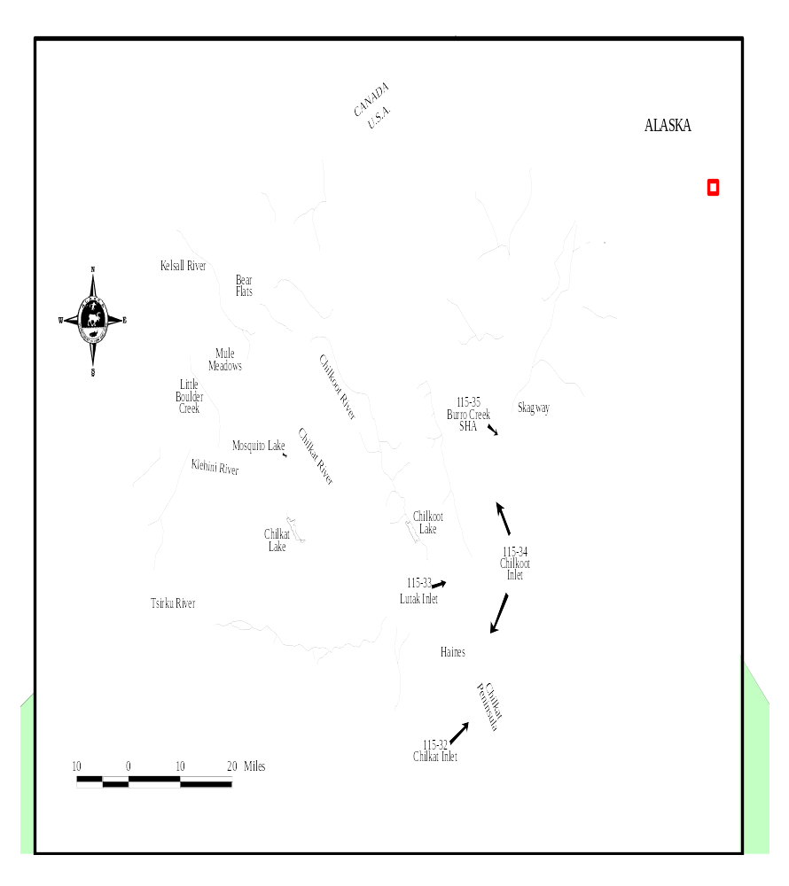
Figure 1.–Upper Lynn Canal with principle sockeye salmon spawning and rearing areas.

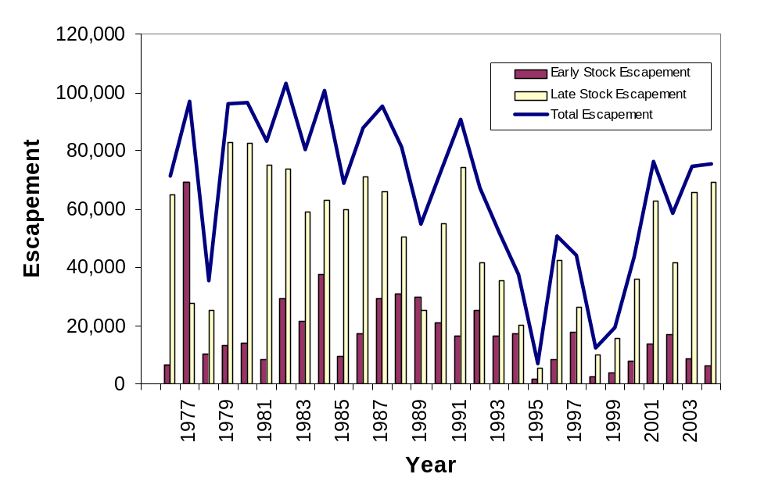
Figure 2.–Annual escapement of Chilkoot Lake sockeye salmon from 1976 to 2004.

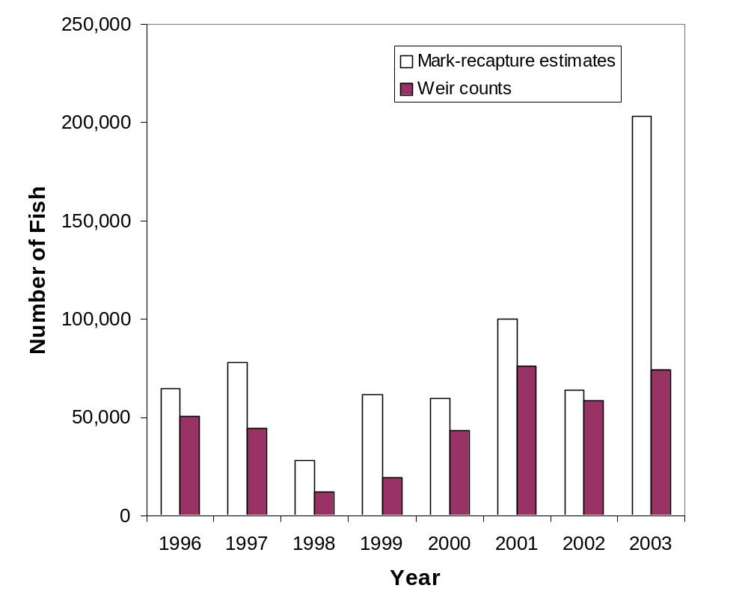
Figure 3.–Comparisons of weir counts and mark-recapture estimates from 1993 to 2003.

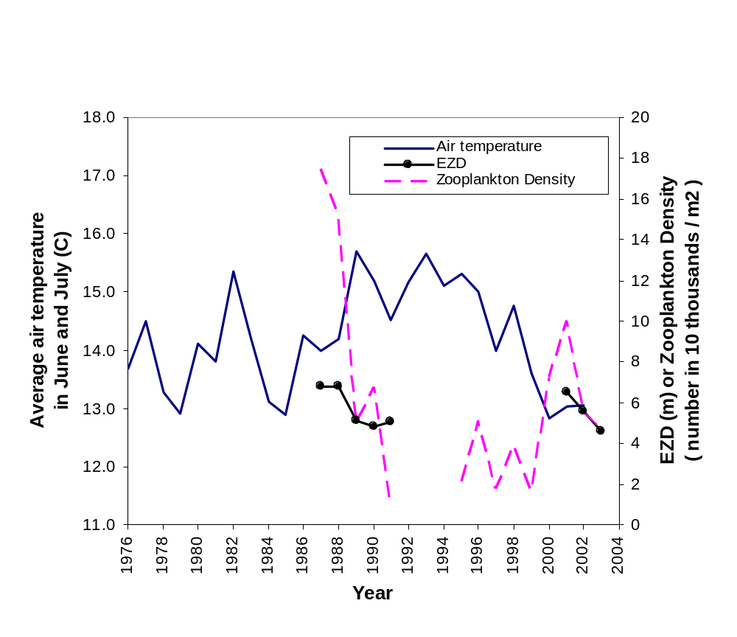
Figure 4.–Average air temperature in June and July, average euphotic zone depth (EZD, m) from May to October, and average zooplankton density (number in 10 thousands per m²) from May to October.

The history of escapement goals for Chilkoot lake sockeye salmon
The sockeye salmon escapement goals for the Lynn Canal lake systems, including Chilkoot and Chilkat lakes, were first set in 1976 by measuring the surface area of each lake and back-calculating (using estimated sex ratios, fecundity, and mortality) to determine the number of spawners that would produce 5,000 rearing fry per surface acre (Euphotic Volume Model; Koenings and Burkett 1987). The escapement goals were set as a range of 80,000±10,000 for each individual lake (McPherson 1990). The escapement range for Chilkat Lake was revised to 70,000±10,000 in 1983 based on a recalculation of surface area and a limited spawner-recruit analysis. Neither of those analyses addressed the possibility that multiple stocks could exist within these lakes, nor did these goals address temporal structure in the spawning stock. The Alaska Department of Fish and Game initiated a program in 1980 that identified Chilkoot and Chilkat lake sockeye stocks in the fisheries and allowed management biologists to regulate the fisheries based on sockeye returns to these individual systems. McPherson (1990) first developed a scale pattern analysis to identify stocks of Lynn Canal sockeye salmon, and Chilkoot and Chilkat lakes were thus treated separately in the analyses of escapement and return data.
Using a Ricker stock-recruit analysis, with total catches and weir counts from 1976 to 1984 brood years, McPherson (1990) established an escapement goal range in 1990. He recommended an overall escapement goal of 50,500–91,500 sockeye salmon, divided into separate goals for early and late stocks. For early stocks, the escapement goal range was 16,500–31,500 spawners; for late stocks, the escapement goal range was 34,000–60,000 (Geiger and McPherson 2004). The escapement goals have not been updated since a discrepancy between the mark-recapture estimates and the weir counts was discovered in 1996.

Escapement Goal Analysis

Ricker recruitment law
Traditionally, escapement goals in Alaska have been developed using a Ricker analysis. This method of analysis is based on the Ricker conceptual model of recruitment, which relates stock size to recruitment using two parameters. Let S be the number of spawners in the escapement in a given year and let R be the number of adult offspring (recruits) that S produces. Note that the recruits might return to the lake over several years. The Ricker law contains two parameters: an acceleration or productivity parameter, called α; and a slowing or density dependent parameter called β. Statisticians have modified the Ricker recruitment law by adding a lognormal error factor, denoted with ε, which we assume to be normally distributed, independent from year to year, with a mean of 0 and standard error of σ. We will call the Ricker law expressed without error (ε set to 0) the conceptual Ricker model. Then the full, or applied Ricker recruitment law is given as,
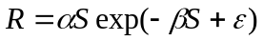.
Typically, the Ricker model is rearranged by dividing both sides by S, taking logarithms and rearranging, so that the equation can be expressed in a form that allows the parameters to be estimated with the following linear regression techniques:

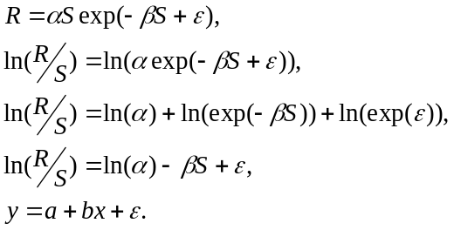
The usual linear regression approach requires that x (in this case stock size) be measured without error, and that ε is independent and identically distributed from one year to the next—two assumptions that are not met in our case at Chilkoot Lake.
Under this stock-recruitment model, the return from an escapement (S) is partitioned into catch, and future escapement. If escapement is held constant, across generations, then three biological reference points can be identified in the conceptual Ricker curve (Figure 5). Let S_{m} denote stock size that maximizes the recruitment. Then S_{m} can be shown to be the same as 1/β by taking the partial derivative of recruitment, setting it equal to zero, and solving for S. The value S_{e}, is the stock size that causes the fish population to be exactly at the system’s “carrying capacity,” so that additional spawners will actually lower the recruitment from the lake. Let S_{y} denote the stock size that produces maximum sustainable catch (Quinn and Deriso 1999). The Ricker model does not have a closed form for S_{y}, and this value must be estimated with numerical methods, using the estimated values of α and β. For the Ricker model, S_{y} occurs when
α (1 - β S_{y})e ^{–βS}_{y} = 1.
Based on this arrangement of the conceptual model, the usual approach to setting an escapement goal is based on the following logic. If the errors in the system (the ε values) are uncorrelated over time, then the estimated Ricker parameters will allow us to predict a kind of average recruitment over time, as a function of stock size. Then if stock size is held nearly constant around the value of S_{y}, then recruitment can be partitioned into S_{y} spawners for broodstock, and the number of fish that are left for yield will be near the maximum possible. Again, the logic of this procedure depends on the ability to estimate the Ricker parameters and to forecast recruitment. In general, the validity of these forecasts depends on the strength of our statistical forecasting model and the future state of the system behaving exactly like the past.
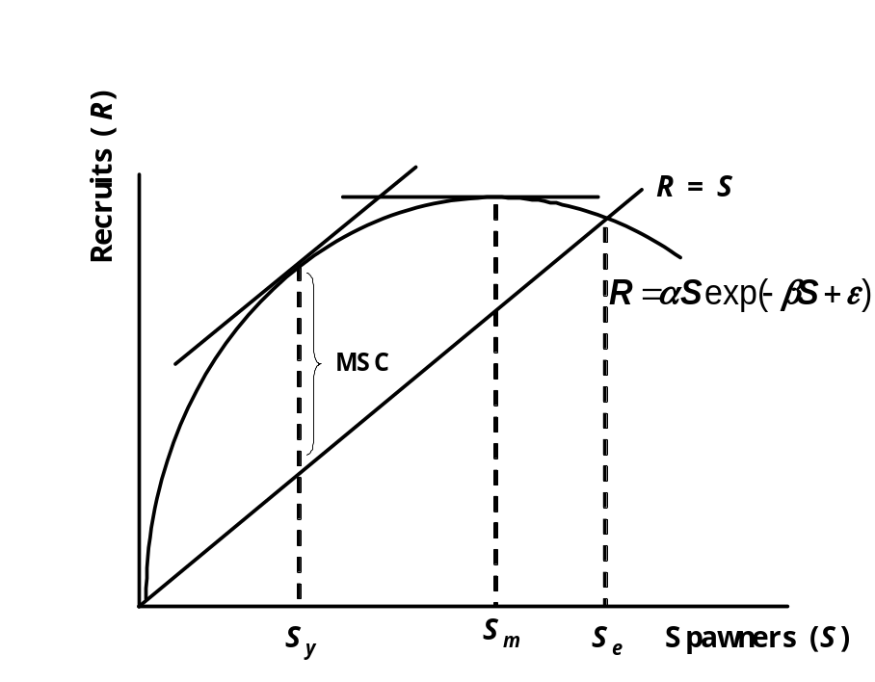
Figure 5.–A conceptual Ricker spawner-recruit curve, relating fish stock size to subsequent recruitment, with three biological reference points noted on the S axis. The value S_{y} denotes the stock size that will maximize catch (MSC), the value S_{m} denotes the stock size that will maximize recruitment, and the value S_{e} denotes an equilibrium point.

Modification of recruitment law

The Bayesian approach
An alternative to the usual linear regression is to estimate parameters for a Ricker model with the Bayesian approach. Let all of the parameters be collectively referred to as θ. Then each set of unknown parameters is assigned a probability distribution, denoted π(θ), and referred to as the prior distribution, as this is the distribution of θ prior to conditioning on the data. Given a time series of observed spawners and recruits, (the S and R values observed over years), the value of the sampling distribution at these specific values is denoted as P(S, R| θ), and the likelihood function of the data is given as a specific set of parameter values for a specified spawner-recruit model. Bayes Theorem is used to calculate the so-called posterior probability density of θ, as follows:
P(θ|S, R) P(S, R| θ) π(θ).
With a probability distribution for the unknown parameters, we can form an estimate by taking a mean, median, or some other feature of this distribution. We can describe uncertainty in the estimate by looking at percentiles of the probability distributions.

Errors in the independent variable
In many systems, escapement may have been measured with error. Let S be the true underlying escapement, and let X denote observed escapement—the value that contains measurement error. Because the observed escapement should always underestimate the actual escapement, as some number of fish pass though the weir undetected each year (Figure 3), we assume that S has a uniform distribution on the interval [X and 2X].

Structural time series Ricker model
To develop a time-series based statistical model, we first lagged values of the logarithm of return per spawner in a transformed Ricker model as follows. Let the values ϕ₁…ϕ_{r} represent parameters that describe how past productivity affects the productivity in year t, as in an autoregressive time series model. Using y, x, and ε as defined above, our structural time series Ricker model can be written as,
.
If the explanatory variable, x, the observed stock size, is removed, then the model is reduced to a univariate autoregressive model. Writing the model in this way is equivalent to a model with a time varying α parameter.
One interpretation of this model is that the productivity of the system is evolving, separately from the random error in the system. To understand the meaning of this interpretation, it helps to re-express the model in the basic Ricker form:
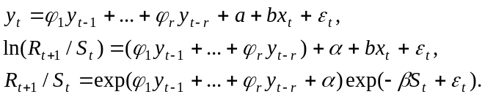
Combining all of the time-indexed elements that do not involve error or stock size into a new time-indexed productivity parameter, which we will call 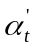, and bringing the stock size factor back to the right hand side of the equation, we can rewrite the model in the basic Ricker form as,
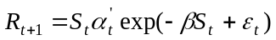.
If shows much variability, this implies that there is no maximum sustainable catch for this stock, and there is no scientific basis for recommending a biological escapement goal, as defined by the Sustainable Salmon Fisheries Policy.

Prior distributions for Ricker associated parameters a and b at Chilkoot Lake
Recall above we re-parameterized the Ricker law, defining a as ln(α) and b as –β, so that we could estimate parameters with the usual linear regression analysis. To find prior distributions, we assumed that a and b are normally distributed with hyperparameters μ₁, υ₁ and μ₂, υ₂, respectively. We found estimates of α values for other Southeast Alaska sockeye stocks that varied from 1.44 to 17.22 (Geiger and McPherson 2004). Previously, McPherson studied Chilkoot Lake and estimated 1/β values of 32,000 for early run and 47,000 for late run (McPherson 1990).

Table 1.–The values of Ricker parameter estimates for sockeye stocks in Southeast Alaska from Geiger and McPherson (2004).
α | 1/β | System
4.04 | 92,000 | Situk River
6.34 | 3,600 | Lost River
5.2 | 14,300 | Italio River
4.31 | 20,200 | Akwe River
4.586 | 15,800 | Klukshu River
5.72 | 85,500 | East Alsek-Doame River
5.54 | 32,000 | Chilkoot Lake (late run)
16.61 | 47,000 | Chilkoot Lake (early run)
4.3 | 35,000 | Chilkat Lake (late run)
8.05 | 47,000 | Chilkat Lake (early run)
4.3 | 23,000 | Redoubt Lake
17.22 | 9,100 | Speel Lake
1.44 | 33,300 | Stikine River

We chose to center the prior distribution of a so that 8 would appear as a kind of typical value. To do that, we let μ₁ be the natural log of 8 with high value of υ₁. Next, we decided to center the prior distribution for b so that 80,000 might appear as a kind of typical value for 1/β and set μ₂ = 1/80,000 with high value of υ₂. The values of υ₁ and υ₂ reflect the confidence in the values of μ₁ and μ₂ we chose. With high values of υ₁ and υ₂, we have low confidence in the prior means of the parameters. The specific values of υ₁ and υ₂ were 10 and 100.

Process error
The random variation notated as ε is called process error in order to keep this source of error conceptually separate from observation error (the difference between X, the observed stock size, and S, the true stock size). Process error is conceptually measured as the variance of ε in the applied Ricker equation, and this variance is denoted as σ². Because we know little about the process error when we began the analysis, we modeled 1/ σ² as having a gamma distribution with two parameters 0.01 and 0.01.

Chilkoot Lake stock-recruit observations
Spikes in the number of returns per spawner from the 1976 and 1995 brood years corresponded to years with a large proportion of the sockeye return composed of younger smaller fish (3- and 4-year olds; Figure 6). More troubling is the fact that the year 1995 was the most influential data point in the analysis, as judged by Cook’s distance (Neter et al 1996); this point will influence the modeling process by causing small stock sizes to appear more productive then they actually are.
Table 2,–Annual estimated return by age and total return (in thousands) by brood year from 1976 to 1997, along with escapement of each brood year for Chilkoot Lake. We used the unadjusted weir counts as our measure of escapement for each brood year and to estimate returns from each brood year; weir counts were used to increase the number of years in our analysis. Cook’s distance estimates were calculated from a least-squares fit of a Ricker stock-recruit relationship.
Brood | Escapement | Age 3 | Age 4 | Age 5 | Age 6 | Age 7 | Total | Return | Cook's
year | in the brood year | return | return | return | return | return | return | per spawner | Distance
1976 | 71 | 0.0 | 9 | 100 | 21 | 0.0 | 130 | 1.82 | 0.00
1977 | 97 | 0.0 | 10 | 199 | 80 | 0.1 | 288 | 2.97 | 0.01
1978 | 35 | 0.0 | 28 | 225 | 24 | 0.4 | 277 | 7.82 | 0.19
1979 | 96 | 0.0 | 17 | 298 | 35 | 0.5 | 351 | 3.65 | 0.02
1980 | 97 | 0.1 | 10 | 172 | 31 | 0.6 | 214 | 2.22 | 0.00
1981 | 83 | 0.0 | 17 | 149 | 112 | 0.7 | 279 | 3.34 | 0.01
1982 | 103 | 0.2 | 18 | 309 | 38 | 2.8 | 369 | 3.58 | 0.03
1983 | 80 | 0.0 | 28 | 274 | 123 | 1.8 | 427 | 5.31 | 0.03
1984 | 100 | 0.0 | 22 | 221 | 117 | 0.6 | 361 | 3.59 | 0.02
1985 | 69 | 0.0 | 14 | 132 | 81 | 0.9 | 227 | 3.30 | 0.01
1986 | 88 | 0.1 | 10 | 216 | 69 | 0.5 | 296 | 3.36 | 0.01
1987 | 95 | 0.1 | 25 | 145 | 55 | 0.1 | 227 | 2.38 | 0.00
1988 | 81 | 0.0 | 5 | 45 | 17 | 0.1 | 67 | 0.82 | 0.02
1989 | 55 | 0.0 | 2 | 44 | 3 | 0.0 | 50 | 0.91 | 0.02
1990 | 73 | 0.1 | 1 | 6 | 6 | 0.0 | 13 | 0.17 | 0.15
1991 | 91 | 0.5 | 6 | 59 | 6 | 0.0 | 71 | 0.78 | 0.04
1992 | 67 | 0.2 | 5 | 65 | 4 | 0.0 | 74 | 1.11 | 0.01
1993 | 52 | 0.2 | 2 | 10 | 4 | 0.0 | 16 | 0.31 | 0.15
1994 | 37 | 0.5 | 1 | 13 | 12 | 0.0 | 26 | 0.69 | 0.09
1995 | 7 | 0.0 | 7 | 37 | 6 | 0.0 | 50 | 6.93 | 0.70
1996 | 51 | 0.0 | 9 | 132 | 2 | 0.0 | 144 | 2.83 | 0.01
1997 | 44 | 0.0 | 5 | 74 | 22 | 0.0 | 102 | 2.30 | 0.00

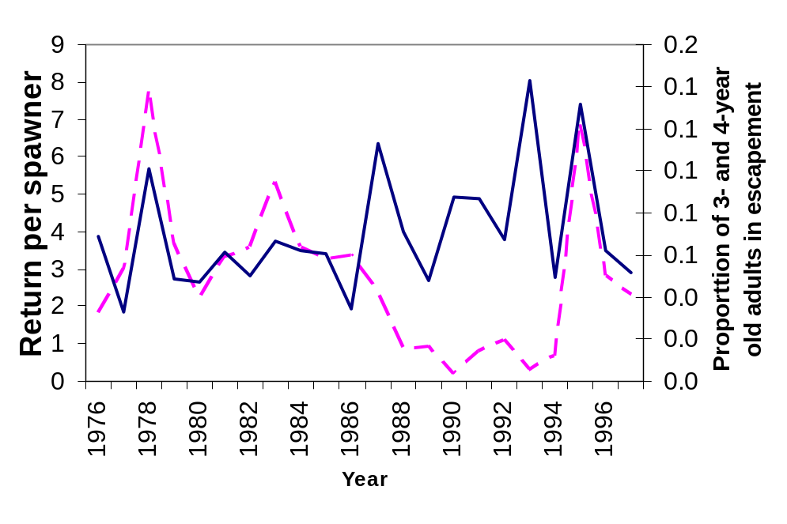
Figure 6 The estimated number of returns-per-spawner for Chilkoot Lake (plotted with a solid line) together with the proportion of 3- and 4-year old adults in the returns (dashed line) from each brood year.

Bayesian model fitting

First model: Ricker relationship with observation error
The Bayesian posterior distributions of key parameters in our first model (without the autocorrelation terms) are badly skewed (asymmetric; Figure 7). Note also that the posterior median estimates of the stock size that will produce maximum sustained catch, S_{y} =117,500, are larger than the total brood-year recruitment for this stock 9 of the last 10 years (Table 3). If process error of the transformed model was normally distributed, and given that prior distributions for the parameters were normally distributed, the posterior distributions of the parameters should also be normally distributed (Gelman et al 2004). On the contrary, the posterior distribution for β reveals that the posterior probability for this parameter is not normally distributed, and the posterior probability is concentrated near the constraint that the value be positive (Figure 7)—a sign that the model poorly fits the data.
An examination of the stock-recruit observations together with an estimated model shows that the stock-recruit observations do not show a pattern of recruitment decline with higher escapements. Our fist stock-recruit analysis failed to find a carrying capacity estimate for this system (Figure 8). An examination of the model residuals showed a lack of statistical stationarity, or stability though time (Figure 9), providing further that this stock-recruit analysis failed to determine a maximum sustained catch level for this stock.

Table 3.–The Bayesian inferences about parameter and reference points in the model without autocorrelation terms for Chilkoot Lake. The parameter α is the productivity parameter; S_{m} is stock size that maximizes the recruitment; S_{y} is the estimate of the escapement that will maximize sustained yield.

 | α | S_{m} | S_{y}
1st Quartile | 2.32 | 150,700 | 80,800
Median: | 2.99 | 262,600 | 117,500
Mean: | 3.56 | 2,546,900 | 756,300
3rd Quartile | 4.11 | 571,200 | 212,500

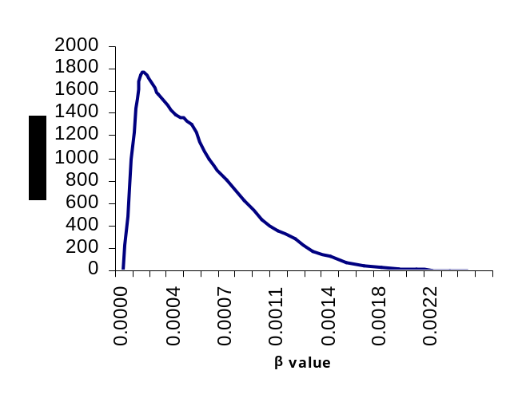
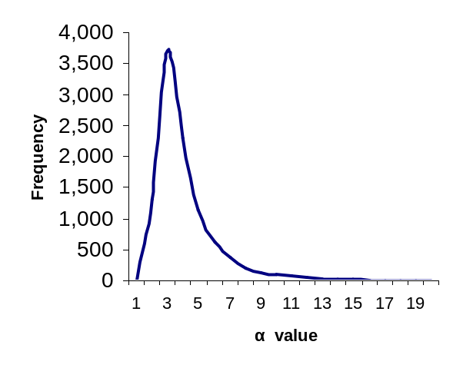
Figure 7.–Posterior distributions for Ricker model parameters α (on the left) and β (on the right) for Chilkoot Lake.

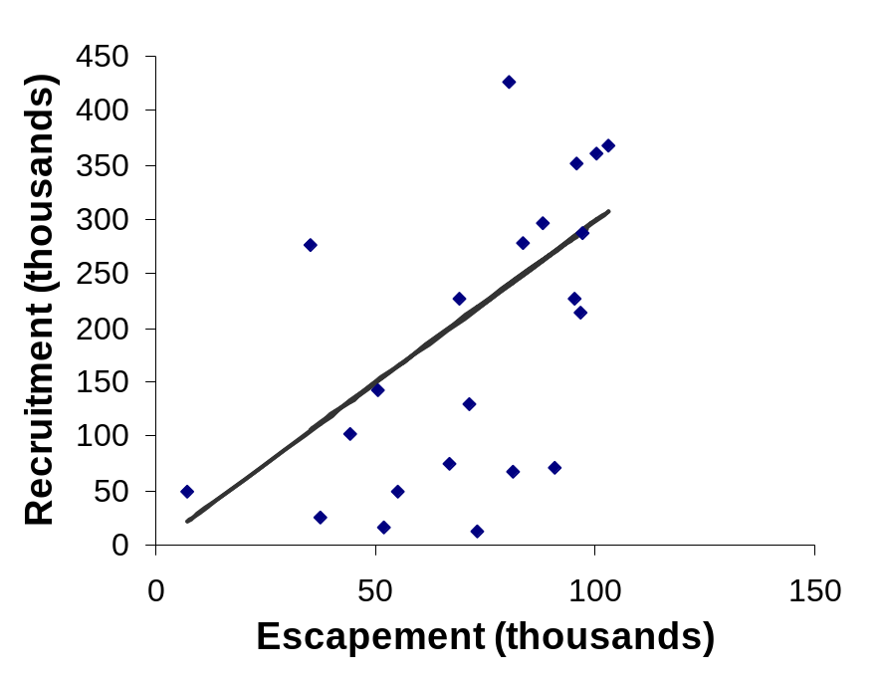
Figure 8.–Spawner-recruitment observations for Chilkoot Lake, together with the Ricker relationship, which shows continuous increase in recruitment throughout the range of observed escapements. Note the inability of this model to determine the stock’s carrying capacity.

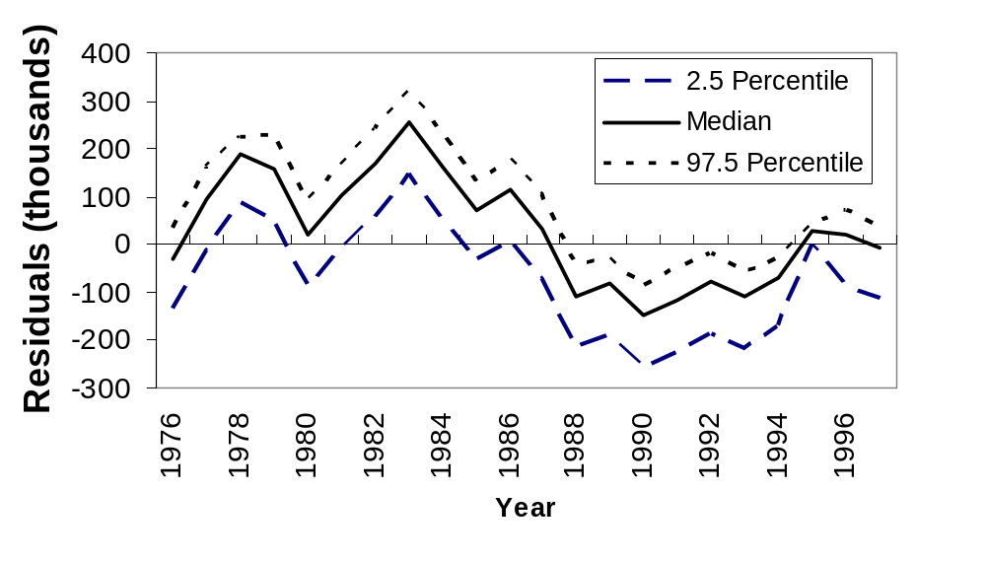
Figure 9.–Residuals for a Bayesian Ricker model developed without a time series component for Chilkoot Lake. The median, 2.5, and 97.5 percentiles refer to the posterior distributions of the Ricker parameters.

Second model: Structural time series Ricker model
The graph of the residuals from the first model (without a time series component) suggested that dependent variable y is correlated with itself in time, or autocorrelated (Figure 9). The pattern of autocorrelations of the logarithm of return per spawner in Figure 10 suggests a first-order autocorrelation process, which we implemented in our structural time series notation as,
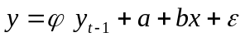.
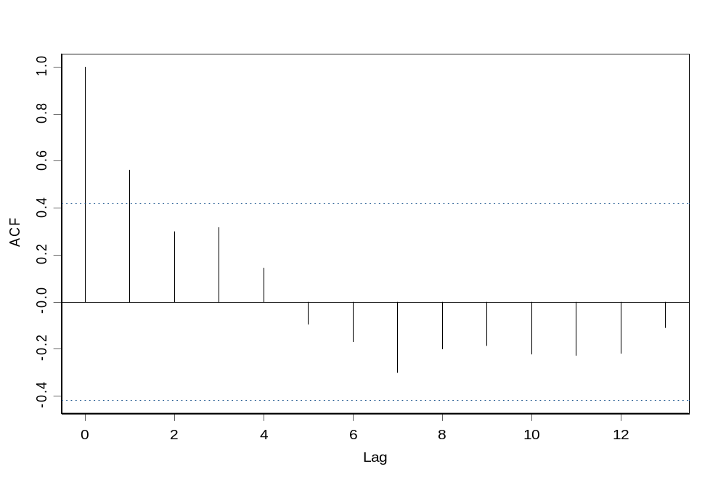
Figure 10.–Autocorrelation of logarithm of recruits per spawner for Chilkoot Lake. This pattern indicates a first order autoregressive process.
Table 4.–Some key posterior distribution summaries for a structural time series Ricker model for Chilkoot Lake. The percentile refers to the Bayesian posterior distribution. The Ricker α_{t} value is from the posterior distribution for the most recently completed brood year: 1998. The value of S_{m}=1/β is the stock size that produces maximum recruitment, and is the inverse of the Ricker β parameter. Because of the time-varying nature of the α_{t} value, there is no maximum sustainable catch (MSC), but we define the “instantaneous” stock that will produce maximum sustained catch to be the value if α_{t} were to be held constant across time.

Bayesian posterior Percentile | α₁₉₉₈ | S_{m}=1/β  (thousands) | Stock size that produces “instantaneous” MSC
0.1 | 2.51 | 76 | 57
0.2 | 2.97 | 93 | 65
0.25 | 3.18 | 101 | 68
0.3 | 3.41 | 109 | 72
0.4 | 3.91 | 128 | 79
0.5 | 4.46 | 151 | 89
0.6 | 5.12 | 185 | 101
0.7 | 5.99 | 234 | 120
0.75 | 6.47 | 273 | 133
0.8 | 7.08 | 327 | 153
0.9 | 9.29 | 572 | 242

The structural time-series approach resulted in some improvement in the model fit to the data. A graph of the residuals from this model, though showing a better fit than our first model, still showed lack of fit to the early years of the time series and the most recent years (Figure 11). The 95% Bayesian credible interval for the stock size that would produce maximum sustainable catch for the next few years ran from 68 thousand to 133 thousand—a very wide range that includes the current escapement goal range (55.5 thousand–91.5 thousand).
However, this model produced an α, or stock productivity parameter estimate, that changed rapidly from year to year (Figure 12); a result that is inconsistent with the concept of a maximum sustainable catch level that can be sustained though time. In addition, figure 12 indicates that the stock’s productivity changed considerably within a three-year period, as illustrated by the four recent year-specific stock-recruit relationships (Figure 13).

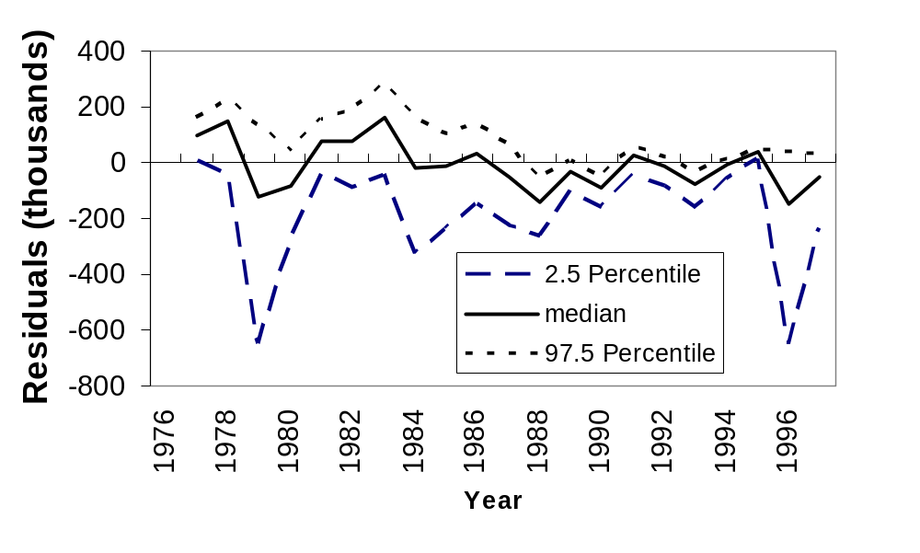
Figure 11.– Residuals for a Bayesian Ricker model developed with a time series component for Chilkoot Lake. The median, 2.5, and 97.5 percentiles refer to the posterior distributions of the Ricker parameters.

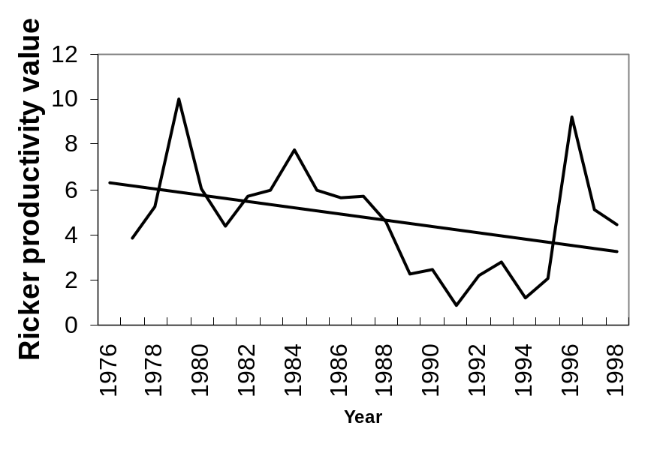
Figure 12.–Estimated median time-indexed Ricker productivity parameter for a structural time series Ricker model.

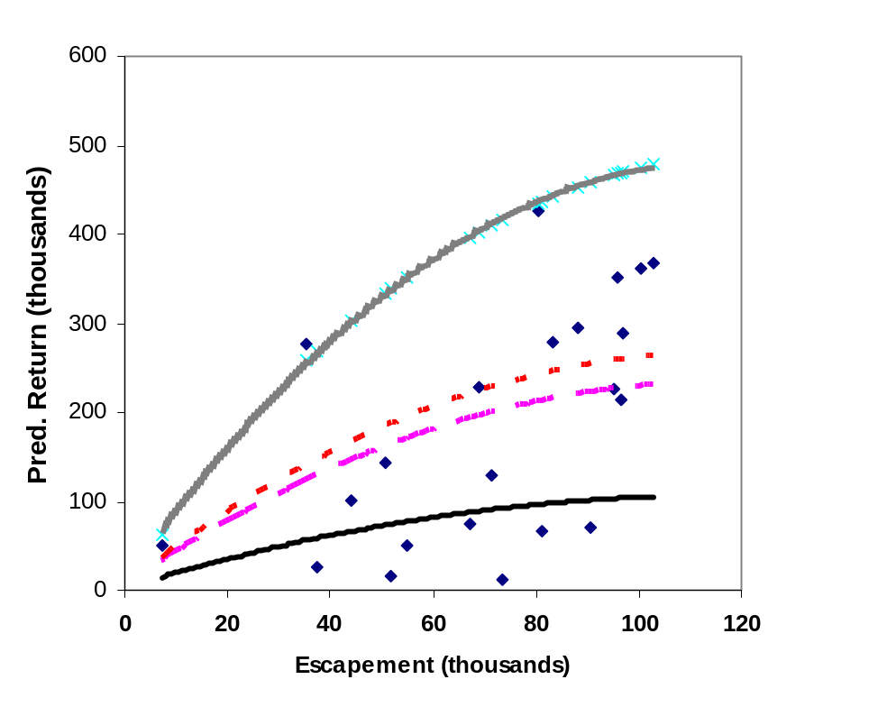
Figure 13.–Comparison of four year-specific stock-recruit relationships, generated by using time-indexed Ricker α values from a structural time-series model. Lines are model predictions for the 1994 to 1997 brood years and dots show all stock-recruit observations.

Escapement Goal Recommendation
All though we attempted the usual escapement goal modeling approach and extensive modifications to this approach to allow time-varying parameters and errors in stock size measurements, we could not find any model or stock-recruit analysis that led to a reliable estimate of an escapement size producing a maximum sustainable catch. The stock’s productivity has changed quickly in the recent past, and these changes have been so extreme as to defeat our statistical modeling procedure. Indeed the changing nature of this stock implies that no maximum sustainable catch is currently possible, even over a very short time. The definition of a biological escapement goal is centered on the idea of a maximum sustainable catch, and a strong assumption that the stock’s average performance to be roughly constant from year to year. We cannot estimate a maximum sustainable catch for this stock at this time; we believe we have shown that this system is too unstable to produce a forecastable maximum sustainable catch at this time. Therefore, we are unable to recommend a biological escapement goal for the Chilkoot stocks.
Alternatively, the escapement goal established by McPherson was produced before the recent changes in stock productivity with a well documented analysis. Indeed, McPherson’s goal is contained within the 95% Bayesian credible interval for the short-term maximum sustainable catch for this system. For that reason, we recommend that the Chilkoot Lake sockeye salmon escapement goal remain essentially unchanged and be classified as a sustainable escapement goal. For simplicity, we recommend rounding this goal from 50.5 thousand to 91.5 thousand to 50 thousand to 90 thousand.

Stock Status and Discussion
The status of the Chilkoot stock can be described as unfavorable from a fisheries management perspective. In recent years the system’s managers have responded to the stock’s decline in recruitment by reducing the harvest of this stock, and consequently the escapement into this system has been within the overall escapement goal range every year since 2001. We concluded that this stock’s downturn in productivity started with the 1989 brood year and continued to decline, uninterrupted, until about the 1995 brood year (Figure 9; Table 2). Riffe (2006) hypothesized that this downturn was due to changes in freshwater conditions brought on by local warming. In her view, glacial melt in some years has drastically reduced the available rearing area for sockeye salmon reducing both the year-to-year stability of the lake and reducing the sockeye food base in some years.
The low zooplankton measurements in Chilkoot Lake (Figure 4) are the strongest indirect evidence that freshwater conditions were responsible for the downturn. Although both the Chilkat and the Chilkoot rivers both flow into northern Lynn Canal, each has had a very different pattern of recruitments, which appears to rule out the shared marine environment as the source of the lowered survival for the Chilkoot sockeye stock. Moreover, during this same period several low recruitments to the Chilkat Lake have been carefully documented as having resulted from freshwater conditions in that system (ADF&G, unpublished data). Similarly, we cannot identify any fisheries that we think could have been selectively intercepting Chilkoot Lake bound sockeye salmon. So, through a process of elimination of fisheries mortality and low marine survival for the sources of the survival decline, together with the measured decline of zooplankton in the lake, we feel comfortable concluding that the decline in the Chilkoot stock can be traced back to lowered freshwater survival.
Our original intent was to use a stock-recruit analysis (Quinn and Deriso 1999) to set an escapement goal for Chilkoot Lake. The underlying logic behind the stock-recruit analysis is that we can use escapement level to reliably forecast production out of the lake. For the maximum sustainable catch approach to have meaning, the lake system must be stable. Clearly, the production out of Chilkoot Lake cannot be forecast at this time because the system’s response to escapement is vastly different from year to year. The failure of stock-recruit analysis for this system is about as clear a failure as we have ever seen.
Still, we feel that we should make two recommendations about escapement. First, if the lake does eventually stabilize, the productivity and carrying capacity are likely to be different from these characteristics of the stock from the past. Once the lake finally does stabilize, we will need some measurements of the recruitments at large stock sizes to estimate carrying capacity of the system, if we want to use a stock-recruit analysis to set an escapement goal at that time. This should argue for escapement goals that will produce at least some large escapements. However, before the lake does stabilize, large escapements will be of little benefit to future yields. This should argue for escapements that are small, but still sustained and not declining. Consequently, we have recommended essentially no change in the escapement goal, even though we have classified the current recommendation as a sustainable escapement goal to emphasize that our intent is not to provide for maximum sustained catch. We recommend that managers tend to the lower end of this goal range until they see some consistency in recruitments.
We note that our recommended escapement goals are slightly modified from these previous goals (Geiger et. al 2004), in that we have further rounded the goals. Geiger et al. (2004) recommended separate goals for the early and late stocks, which totaled from 50,500 to 91,500. We have rounded these goals more to 50,000 to 90,000, and we recommended weekly targets (Table 5).
Table 5.–Weekly cumulative escapement goals for Chilkoot Lake.
 |  |  | Cumulative | Cumulative
Week | Weekly Goal | Cum. Goal | Lower Bound | Upper Bound
23 | 697 | 697 | 498 | 896
24 | 2,847 | 3,544 | 2,532 | 4,557
25 | 4,918 | 8,462 | 6,045 | 10,880
26 | 4,161 | 12,624 | 9,017 | 16,230
27 | 2,727 | 15,350 | 10,964 | 19,736
28 | 3,260 | 18,610 | 13,293 | 23,928
29 | 5,865 | 24,475 | 17,482 | 31,468
30 | 8,110 | 32,585 | 23,275 | 41,894
31 | 10,219 | 42,804 | 30,574 | 55,033
32 | 9,268 | 52,071 | 37,194 | 66,949
33 | 6,075 | 58,147 | 41,533 | 74,760
34 | 5,168 | 63,315 | 45,225 | 81,405
35 | 3,508 | 66,823 | 47,730 | 85,915
36 | 2,301 | 69,123 | 49,374 | 88,873
37 | 877 | 70,000 | 50,000 | 90,000

references cited
Bachman, R.L. 2003. Fishery management plan for the Lynn Canal (District 15) drift gillnet fishery 2003. Alaska Department of Fish & Game, Commercial Fisheries Division. Regional Information Report. 2003
Bergander, F.E. 1989. Southeast Alaska sockeye salmon studies, 1989;Final report for the period 1 July, 1988 to June 30, 1989. Alaska Department of Fish and Game, Division of Commercial Fisheries, Regional Information Report 1J89-27, Juneau.
Bergander, F.E. 1990. Southeast Alaska sockeye salmon escapement determination; Port Snettisham and Hugh Smith weirs, 1989. Alaska Department of Fish and Game, Division of Commercial Fisheries, Regional Information Report 1J90-20, Juneau.
Bugliosi, E.F. 1988. Hydrologic reconnaissance of the Chilkat River basin. U.S. Geological Survey, water resources investigations report 88-4023. Anchorage
Carlin, B.P and T. A. Louis 1996. Bayes and empirical Bayes methods for data analysis. Chapman & Hall.
Finney, B.P., I. Gregory-Eaves, J. Sweetman, M.S.V. Douglas and J.P. Smol. 2000. Impacts of climatic change and fishing on Pacific salmon abundance over the past 300 years. Science Vol 290: 795-799.
Geiger, H.J. and Koenings, J.P. 1991. Escapement goals for sockeye salmon with informative prior probabilities based on habitat considerations. Fisheries Research, 11: 239-256
Geiger, H. J, 1994 A Bayesian approach for estimating hatchery contribution in a series of salmon fisheries. Alaska Fishery Research Bulletin 1 (1): 66-75.
Geiger, H. and S. McPherson, 2004. Stock status and escapement goals for salmon stocks in Southeast Alaska. Alaska Department of Fish and Game, Special Publication No. 04-02.
Gelman, A, Carlin, J. B, Stern, H. S. and Rubin, D. B. 2004. Bayesian Data Analysis. Chapman & Hall/CRC
Lloyd, D.S., Koenings, J.P. and Barrett, B.M., 1988. Density-dependent, trophic level responses to an introduced run of sockeye salmon (Oncorhynchus nerka) at Frazer Lake, Kodiak Island, Alaska. Can. J. Fish. Aquat. Sci., 45:856-867.
Kelley, M.S. and R.L. Bachman, 1999. Chilkoot River weir results in 1998. Alaska Department of Fish and Game, Region I Informational Report No. 1J99-25.
Koenings, J.P. and Burkett, R.D. 1987. Population characteristics of sockeye salmon (Oncorhynchus nerka) smolts relative to remperature regimes, euphotic volume, fry density, and forage base within Alaskan lakes. In: H.D. Smith, L. Margolis and C.C Wood (Editors), Sockeye Salmon (Oncorhynchus nerka) Population Biology and Future Management. Can. Spec. Publ. Fish. Aquat. Sci., 96:216-234.
McPherson, S. A. 1990. An inseason management system for sockeye salmon returns to Lynn Canal, Southeast Alaska. M. S. Thesis, University of Alaska Fairbanks.
Neter, J. Kutner, M.H., Nachtsheim, C.J. and Wasserman, W. 1996. Applied linear statistical models. WCB/McGraw-Hill 360-382.
Quinn II, T. J. and R. B. Deriso. 1999. Quantitative fish dynamics. Oxford Univ. Press. New York.
Rich, W.H., and E.M. Ball. 1933. Statistical review of the Alaska salmon fisheries part IV: Southeastern Alaska. Bulletin of the United States Board of Fisheries (47): 437-673.
Ricker, W. E. 1975. Computation and interpretation of biological statistics of fish populations. Bulletin 191 of the Fisheries Research Board of Canada.
Riffe, R. 2006. Summary of limnology and fisheries investigation of Chilkoot Lake, 2001—2004. Alaska Department of Fish and Game, Fishery Data Series 06-17, Anchorage.

